**Linkit Technical Design Document**

*Offering a centralized platform for creating, customizing, and sharing personalized link profiles effortlessly and effectively.*

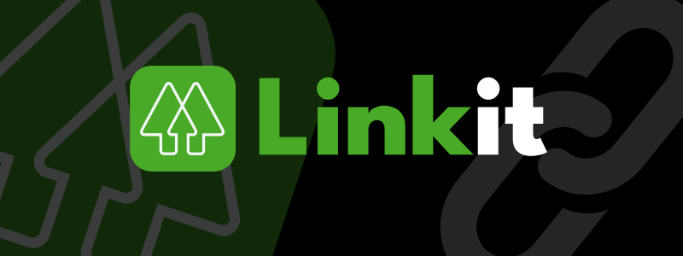

**Preface**

This technical document outlines the architecture, core features, and implementation approach for LinkIt, a MERN stack application tailored for managing and showcasing personalized link profiles. It acts as a roadmap to ensure clarity and collaboration among developers and stakeholders throughout the project lifecycle.

**Scope**

*LinkIt is a web-based platform designed for organizations and digital creators to seamlessly share and manage their social media links in a collaborative environment. The system includes features such as user registration, customizable link profiles, analytics to track engagement, and an admin panel for efficient platform management.*

**Document Structure**

This document is organized into the following sections:

* **System Overview**: High-level description of the system architecture and deployment strategy.
* **Requirements**: Detailed breakdown of functional and non-functional requirements.
* **Technical Design**: Database schemas, API endpoints, and UI/UX components.
* **Testing and Deployment**: Strategies for testing and deploying the application.
* **Future Enhancements**: Planned features and scalability consideration

**TABLE OF CONTENTS**

1. Introduction
2. System Overview
3. Requirements
4. Technical Design
5. Technology Stack
6. Deployment
7. Future Enhancements
8. Appendix

Introduction

* Project Overview

LinkIt is a MERN stack-powered platform designed for organizations and digital creators to efficiently manage and share their social media links. The platform emphasizes personalization, offering customizable link profiles with a sleek UI/UX design and support for light and dark modes. It tracks user engagement by counting unique clicks or views for each account and ranks users based on their engagement metrics. With its seamless interface and data-driven insights, LinkIt empowers users to maximize their online presence and track their influence effectively.

* **Objectives**
  + **Profile Sharing**: Create and share personalized profile pages for social media and important links.
  + **Dashboard Management**: Manage profile pages, links, and performance metrics easily.
  + **Customization**: Design and personalize profile pages to reflect unique branding or style.
  + **Engagement Tracking**: Track profile clicks, unique views, and user rankings for better insights.
  + **Clean UI/UX**: Enjoy a modern, responsive interface with light and dark modes.
  + **Scalability and Security**: Reliable and secure platform for creators and organizations.
* **Target Audience**

The primary audience for LinkIt includes content creators, social media influencers, actors, athletes like cricketers, companies, working professionals, and anyone with an active presence on social media. The platform is designed to simplify the way users share and manage their digital profiles by centralizing links to all their social media pages, websites, and other important online content. LinkIt provides an easy way for people to connect to different pages, offering both individuals and businesses a streamlined solution to showcase their digital presence and enhance engagement with their audience.

System Overview

* **Architecture**

*LinkIt is built on the MERN stack, incorporating MongoDB for efficient data storage, Express.js to handle backend operations, React.js for a dynamic and interactive frontend, and Node.js as the runtime environment. This stack provides a robust, full-stack JavaScript solution for smooth and scalable functionality. For managing profile images, LinkIt leverages Multer for image file handling and Cloudinary for secure cloud storage, ensuring fast, reliable, and scalable image management.*

* **Core Components**
  + Frontend (React.js) :-

The frontend of LinkIt is the part of the platform that users interact with, built using React.js to ensure smooth, fast, and responsive functionality.

#### *Key Features:*

* *Interactive and Adaptive User Interface:*  
  React's component-based structure allows the creation of reusable UI elements, ensuring a consistent and responsive experience across all pages for users on various devices.
* *Effortless Navigation:*  
  Using React Router, the platform provides fluid, uninterrupted navigation between pages such as the Dashboard, Profile Page, and Rankings, maintaining a Single Page Application (SPA) experience without requiring page reloads.
* *Efficient State Management:*Tools like Redux or Context API are utilized to handle the application state, ensuring that user data, links, and engagement details are well-managed throughout the platform.
* *Styling with Tailwind CSS:*  
  Tailwind CSS is employed to deliver a sleek, modern, and responsive design that enhances the user experience and ensures compatibility across different screen sizes and devices.
  + Backend (Node.js and Express.js) :-

The server-side layer of LinkIt is designed to handle requests, execute business logic, and manage data interactions.

#### *Key Features:*

* ***API Endpoints:***  
  Exposes a range of RESTful APIs for tasks such as managing user profiles, updating social media links, and tracking user engagement data.
* ***Request Handling Middleware:***  
  Utilizes middleware for validating incoming requests, handling errors, and ensuring authentication before processing actions.
* ***Optimized for Scalability:***  
  The backend uses Node.js, which ensures non-blocking, asynchronous processing, allowing the system to scale effectively and handle high traffic loads.
* ***Data Integrity and Validation:***  
  Implements robust validation with libraries like Joi or express-validator to ensure data integrity.
* ***Secure Authentication and Role Management:***  
  Uses JWT (JSON Web Tokens) for secure user authentication and role-based access control (RBAC).
  + Database (MongoDB) :-

LinkIt uses MongoDB, a NoSQL database, to store and manage user data and links. MongoDB’s flexible document-based model is ideal for handling dynamic schema requirements, allowing efficient storage of user profiles and associated links. The platform benefits from MongoDB's scalability and performance, making it well-suited to handle growing user engagement.

#### *Key Features:*

* *Flexible Schema:*  
  MongoDB’s schema flexibility enables dynamic definitions, perfect for storing varied user profile attributes such as usernames, emails, passwords, profile images, and profile clicks.
* *Scalability:*  
  MongoDB’s ability to scale horizontally ensures that the platform can handle a high volume of users and data, maintaining performance as the platform grows.
* *Indexes and Search:*  
  MongoDB’s indexing capabilities accelerate search and retrieval of user profiles, links, and engagement metrics, making functions like sorting and filtering seamless.
* *Relationships:*  
  The platform effectively manages relationships between users and their links. Each user can have multiple links associated with their profile, stored in a way that links are connected to user data through references. User attributes, including username, email, password, profileImage, and profileClicks, are well-organized in the database, ensuring smooth operations.
* **Deployment**

The hosting and deployment components ensure the platform is available and accessible to users.

#### *Key Features:*

* *Frontend Hosting:*The React-based frontend is hosted on **Vercel**, ensuring global availability with built-in CDN integration for fast and secure content delivery.
* *Backend Hosting:*The Express.js server is also hosted on **Vercel**, leveraging its serverless functions for scalable and high-performance backend processing.
* *Database Hosting:*The database is hosted on **MongoDB Atlas**, a cloud-based solution offering automatic backups, multi-region clustering, and advanced monitoring for seamless database management.
* *CI/CD Pipelines:*Automated testing, building, and deployment processes are handled using **Vercel's built-in CI/CD capabilities** and tools like **GitHub Actions**, ensuring a smooth development workflow with continuous integration and delivery.

REQUIREMENTS

* **Core Features**
  + **Profile Sharing**Create, manage, and share personalized public profile pages with social media links.
  + **Link Management**Add, edit, and delete social media and professional links to your profile page.
  + **Customization**Personalize profile pages with images and unique link attributes to enhance visibility and engagement.
* **User Management**
  + **Registration**New users can register with their email and password to create a personal account.
  + **Login**Secure login using email and password to access and manage the user profile.
  + **Profile Management**Users can edit their profile, upload images, and track profile clicks and engagement metrics
* **Link Listings**
  + **Adding a New Link**Users can add a new link to their profile, such as social media pages or professional portfolios.
  + **Editing Link Details**Update link titles and URLs directly from the dashboard.
  + **Deleting Links**Remove unwanted or outdated links from the user profile.
  + **Public Profile Page**Create a public-facing profile that showcases all added links and personal information.
* **Engagement Analytics:**
  + **Tracking User Engagement**Track the number of views or clicks on each user profile and their shared links.
  + **User Ranking**Rankings based on profile clicks and overall engagement across the platform.
* **Security Considerations**

#### **Authentication**

* JWT Tokens:
  + **Secure Generation and Signing:**JWT tokens are securely generated and signed with a secret key to authenticate users.
  + **Storage in localStorage:**Tokens are stored in the client’s localStorage to maintain user sessions across different pages.
  + **Expiration:**Tokens are set to expire after a specific duration to mitigate risks related to token misuse and unauthorized access.
* Password Security:
  + **Password Hashing:**User passwords are securely hashed using bcrypt before storing them in the database.
  + **No Plain-Text Storage:**Plain-text passwords are never stored or logged to prevent potential breaches.

#### **Authorization**

* Protected Routes:
  + **Protected Routes:**Backend API routes are accessible only when a valid JWT token is included in the request header, ensuring secure access to resources.
  + **Frontend Restrictions:**Sensitive frontend actions, such as adding or managing links and customizing profile pages, are restricted using React's higher-order components (HOCs) or context-based access checks.
* Input Validation:
  + **Client and Server-Side Validation:**Validation rules are enforced on both the client and server sides to ensure data integrity and prevent malicious data from being processed.

#### **CORS Configuration**

* Access-Control Policies:
  + The backend is configured to allow requests only from trusted origins, such as the Linkit frontend URL hosted on Vercel.
  + Proper headers are set for:
    - Access-Control-Allow-Origin: Restricts requests to authorized domains
    - Access-Control-Allow-Methods: Limits HTTP methods (e.g., GET, POST, PUT, DELETE) based on functionality.
    - Access-Control-Allow-Headers: Specifies the required headers like Authorization, Content-Type, and Accept.

TECHNICAL DESIGN

1. DataBase Design

* user
  + username: The unique username chosen by the user.
  + email: The email address used for user login (unique).
  + password: The hashed password for user authentication.
  + profileImage: URL for the user’s profile image stored in Cloudinary.
  + profileClicks: The total number of visits to the user's public profile page (default is 0).
* Links
  + userId: Reference to the User who created the link (Foreign Key).
  + title: The title or label for the link.
  + link: The actual URL of the link.

#### One-to-Many Relationship

* User to Links: There is a one-to-many relationship between User and Links, where:
  + A User can have multiple Links.
  + Each Link is associated with exactly one User.

This structure allows users to manage multiple links and showcase them on their public profiles, while also tracking their profile clicks. The relationship ensures that each user can have a personalized set of links, and the platform can display the corresponding links on the user's profile page.

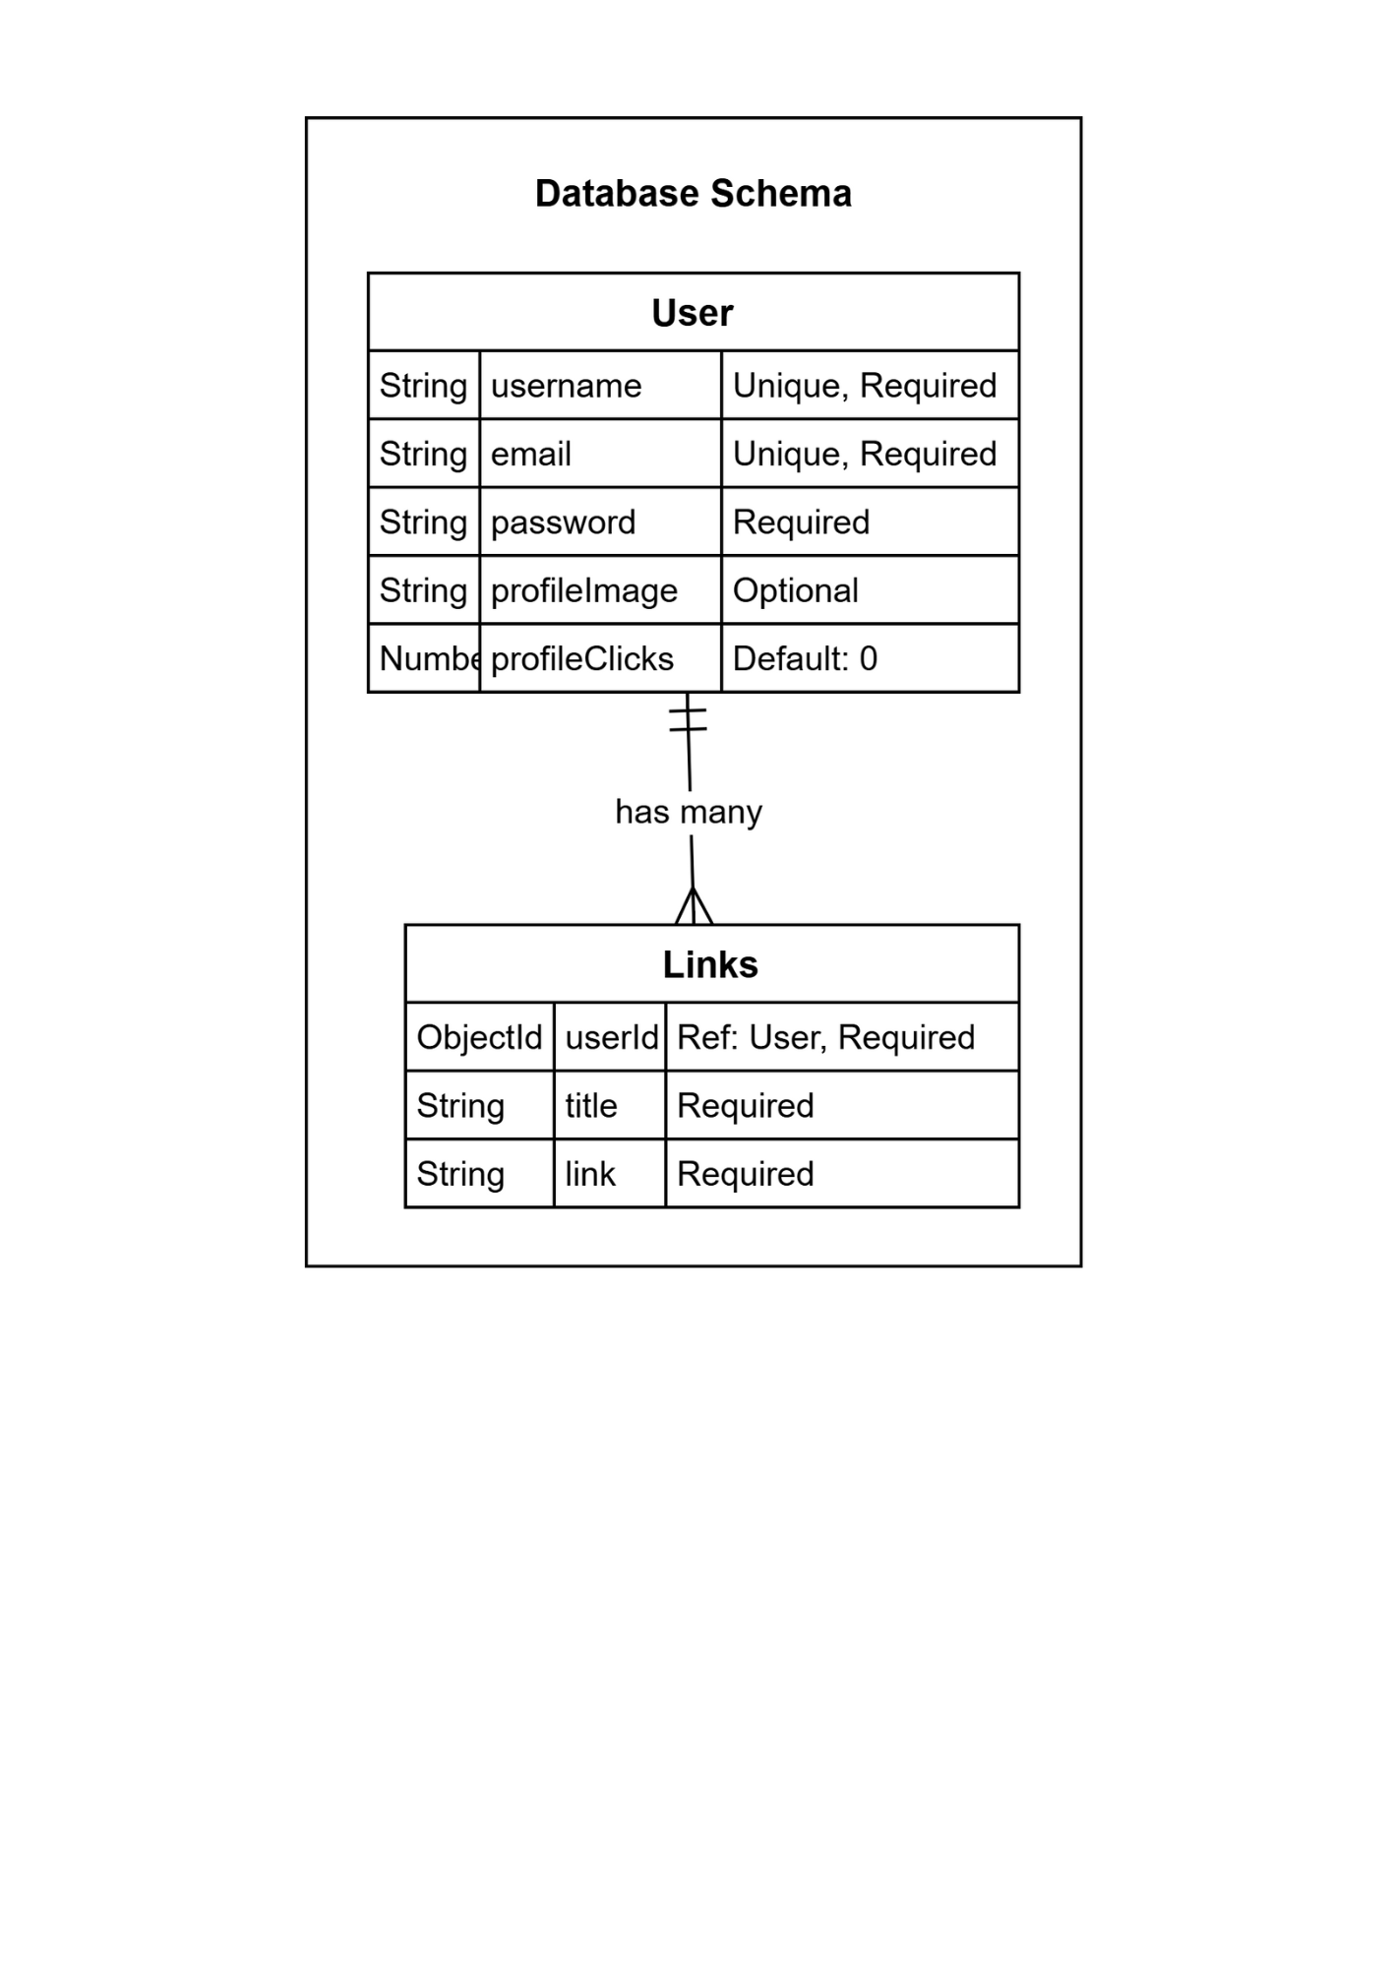

1. Backend Design

* API Route

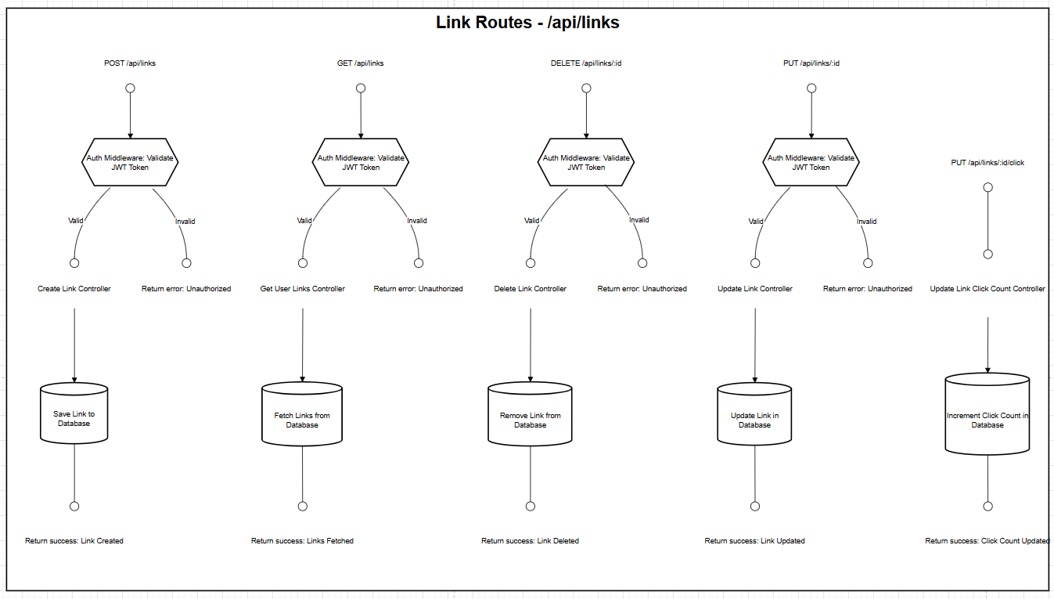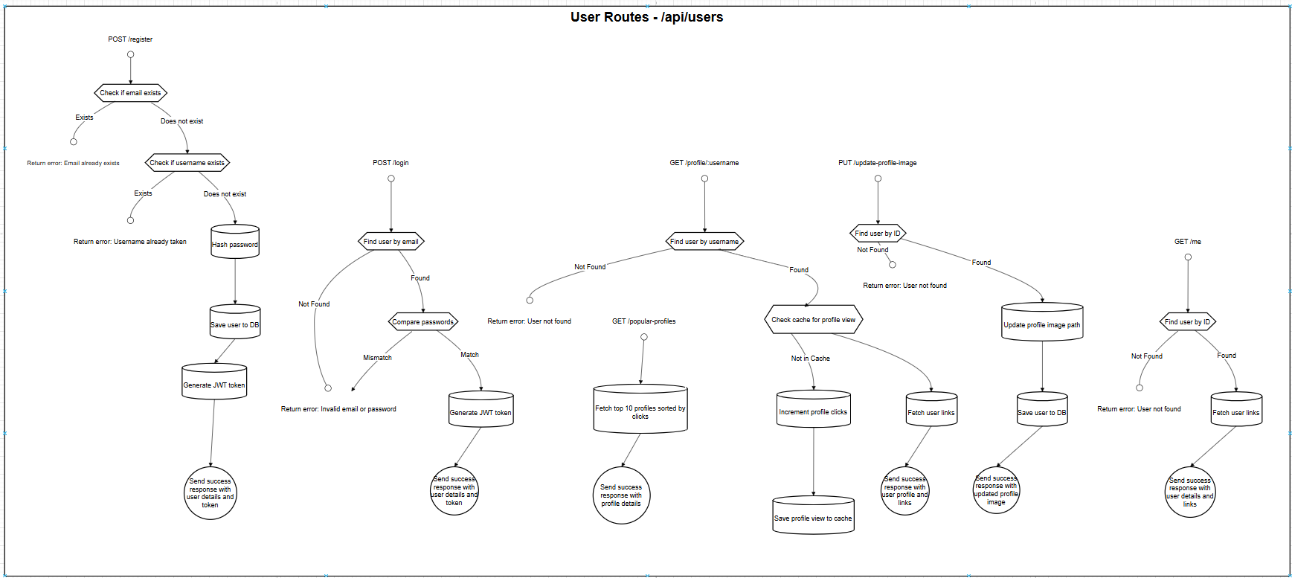

* Services

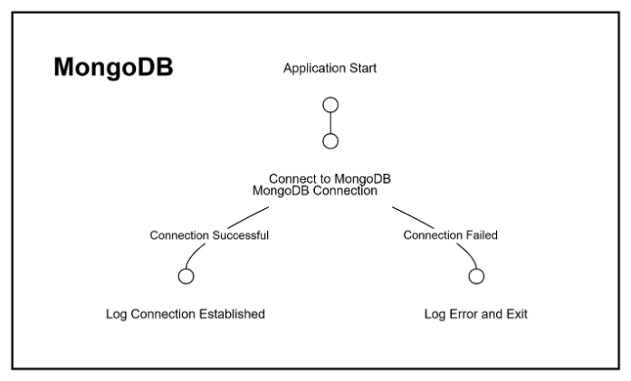

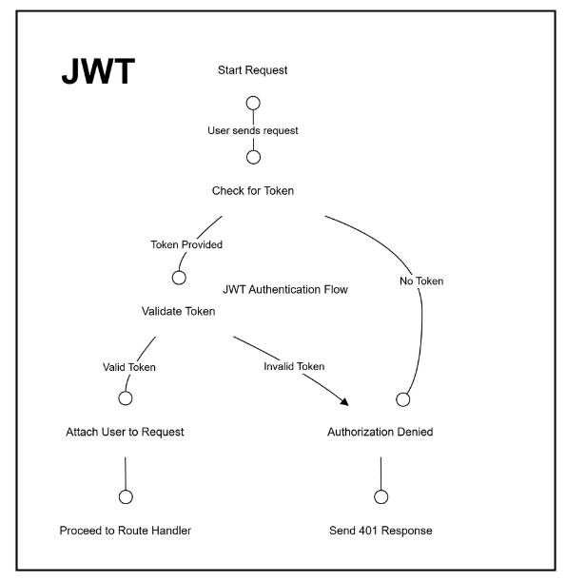

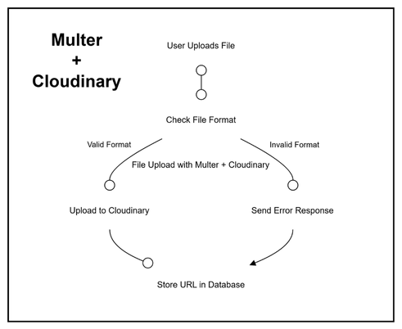

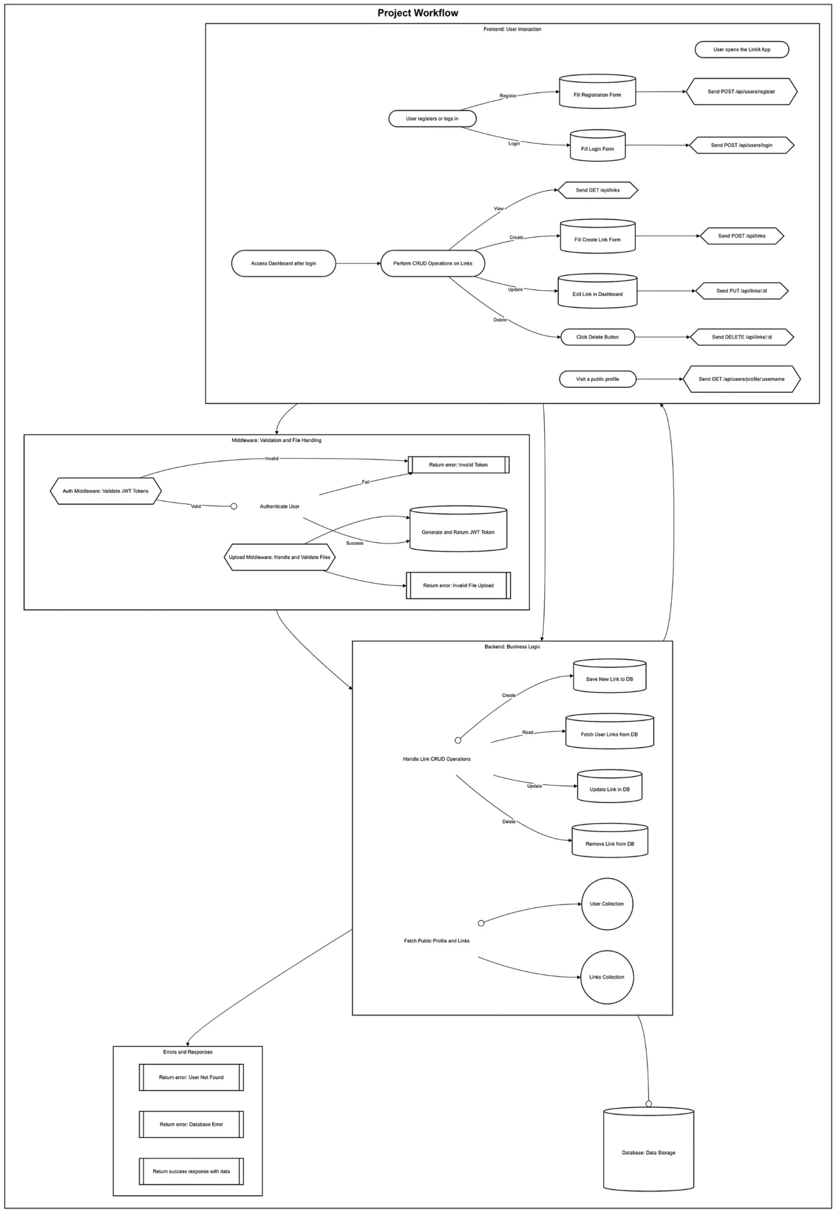PROJECT WORKFLOW

FUTURE ENHANCEMENTS

1. **Scalable and Customizable Public Link Pages:**
   * Linkit allows users to create and personalize their public profile pages, making them scalable and flexible for any type of user, from content creators to businesses.
   * Users can design their pages by adding custom attributes such as social media links, profile pictures, and personalized descriptions, creating a unique and professional presence.
2. **Real-Time Engagement and Analytics:**
   * Linkit provides real-time tracking of user engagement on their public profile pages, including clicks, views, and interactions with their social media links.
   * This data can be used to optimize and customize the user experience, allowing users to track the popularity of their profiles and adjust content accordingly.
3. **Monetization and Revenue Generation:**
   * Users can monetize their public profile pages by integrating ads, sponsored content, or affiliate links, enabling them to earn revenue based on the engagement their pages receive.
   * Linkit supports scalable revenue generation opportunities, providing users with the tools to create value and capitalize on their online presence.

APPENDIX

#### **Conclusion**

Linkit is an innovative platform built to empower individuals, content creators, businesses, and organizations by providing a seamless and customizable solution for managing and sharing social media links. With its user-friendly design, real-time engagement tracking, and scalability, Linkit offers a comprehensive environment where users can easily curate and manage their online presence. By focusing on personalization, monetization, and providing valuable analytics, Linkit transforms how users connect with their audience, providing them with the tools to grow their reach and generate revenue. This platform sets a new standard for social media management, enabling users to enhance their digital identity and maximize their impact online.

#### **References / Documentations**

**Frontend Technologies**

* [React](https://legacy.reactjs.org/)
* [React Router](https://reactrouter.com/)
* [AOS](https://www.npmjs.com/package/aos)
* [Tailwind CSS](https://tailwindcss.com/)

**Backend Technologies**

* [Node.js](https://nodejs.org/en)
* [Express.js](https://expressjs.com/)
* [MongoDB](https://www.mongodb.com/docs/)
* [Mongoose](https://mongoosejs.com/docs/)
* [Bcrypt](https://www.npmjs.com/package/bcrypt)
* [JWT](https://jwt.io/introduction/)
* [Cloudinary](https://cloudinary.com/home)
* Multer

**Tools**

* [Postman](https://www.postman.com/)
* [Figma](https://www.figma.com/)

THANK YOU VERY MUCH !